Hot Sauces to use: Use on top of meats, rice, veggies, etc.
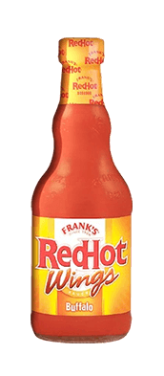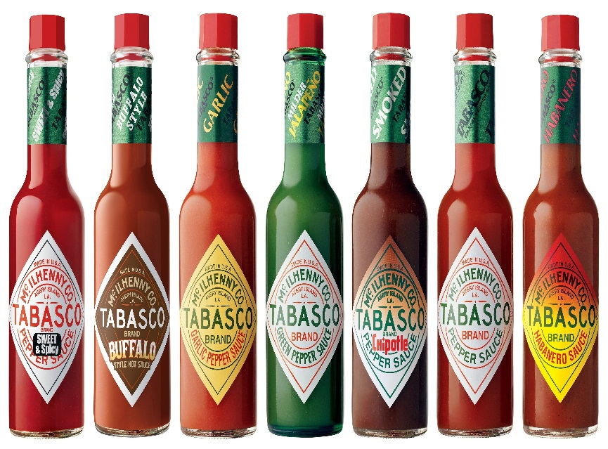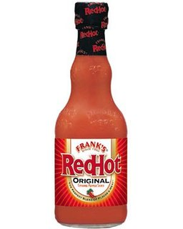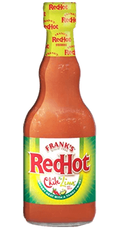

Syrups to use: add flavor to oat meal + protein Shakes + Ezekiel bread + sweet potatoes
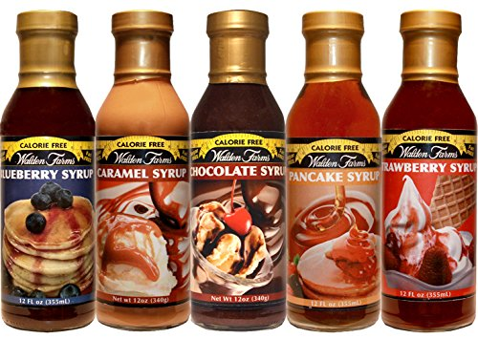

Dressings: These are form Walden Farm – My favorites are Super Fruit Balsamic, Honey Balsamic, Pear and White Balsamic, and Bacon Ranch – Another favorite is the last image by Maple Grove Farms
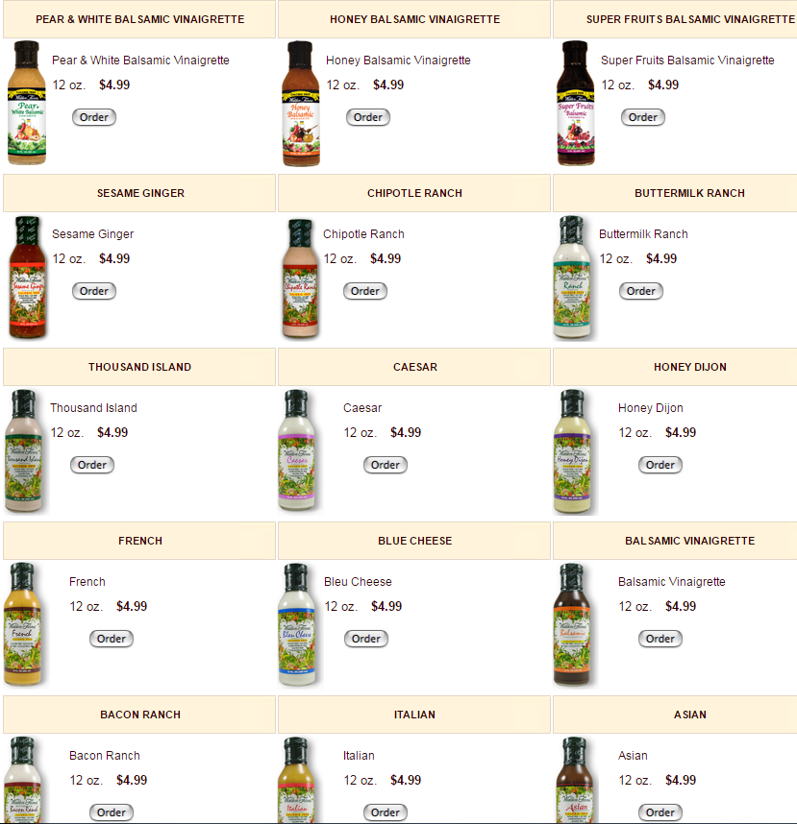
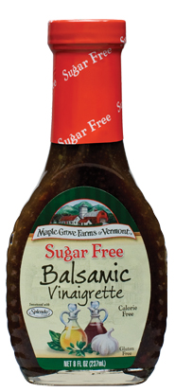

Mayo to use: Walden Farms – can use over salads, add to meats, if using tuna try these
